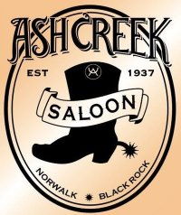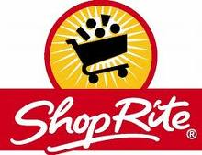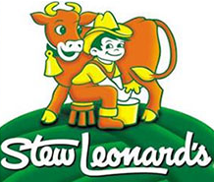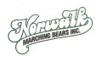
5%
10%
Cranbury Market
10%
5%
10%

Dear Band Family Member,

We want to let you know about a super easy opportunity to support the Norwalk High School Marching Bears that WON'T COST YOU A PENNY!

We all shop for groceries... well, now every time you shop at your favorite store, the store will make a $ donation to the band!

This is how it works ...for example: You purchase a $100 card for Stews. You buy $100 in groceries from Stews as usual & pay with the card at the register. Stews contributes $10 to the band.
IT'S THAT EASY!

We sell cards for Stew Leonard’s, Stop & Shop, Shop Rite, The Cranbury Market & Ash Creek Saloon. The names and contact info for our friendly sellers is on the bottom of this flyer.

Please see one of our sellers at the field during pick-up or call one of us to arrange delivery.

LET'S GET EVERY BAND FAMILY USING GROCERY CERTIFICATES!

Thanks for your support!
The Grocery Certificate Seller Team

Laraine Mehr-Turlis laraine_turlis@yahoo.com
Debby Denke (203) debbydenke@gmail.com (203) 216-1730
Daniela O’Callaghan danielaoc@optonline.net (203) 219-6820
Karen O’Connor karenoconnor1119@gmail.com (203) 223-3392
Nancy Sciglimpaglia (Jazz) sandnscig@yahoo.com (203) 856-3063

